Paschal Nchimbi

pnchimbi@gmail.com

Abstract

Product Requirements Document of a real estate app project.

Mobile app

Real Estate App

# Introduction

House hunting? Get rid of the hustle of searching for a house, have the convenience of searching using your phone.

Tired of paying the dalali a month’s worth of rent, let the app bring the owner of house and potential tenant closer.

Enter: <App Name>

This is ……………………

# Objectives

# Basic Architecture

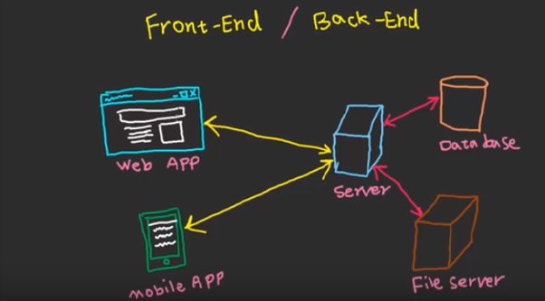

Using REST API, the mobile app will be able to perform GET/POST queries. Database will contain User Account information, house information etc. Fileserver which acts as the data repository will store uploaded images/videos.

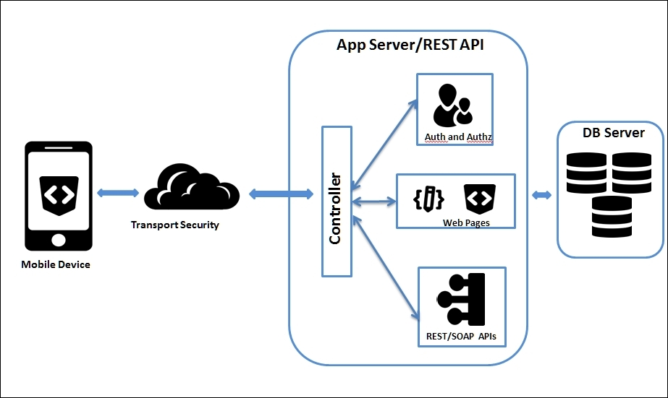

# Objectives

The app will have the following users;

|  |  |
| --- | --- |
| **Type** | **Role** |
| Admin | Super Admin |
| Owners of Houses | These will be able to advertise their houses. Rent/Sale |
| Potential Tenants | Ssearch for houses |
| Dalali | *** to show houses if owner is not available to do so. |

# User Flow

## House Owner

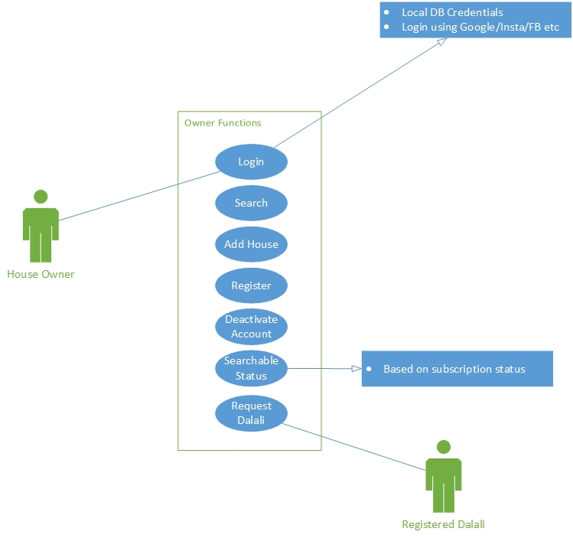

1. Register – Owner of the house must be able to register an account on the system. Personal details include but are not limited to

* First name + surname
* Residential Address - Where they reside
* Email address
* Phone number - max 2 numbers
* Username – automatically derived from registered first name + surname
* Password

1. Login – user should be able to login using locally created account or the integrated google sign-in, FB/Instagram etc.
2. Search – User should be able to search for houses that have been advertised. Search filters include price, entered location/GPS location, number of rooms etc
3. Advertise House – user should be able to advertise house. This house will be searchable for specified period of time. The following can be captured when adding a house

* Required house information – this includes location (can be different from where the owner resides), number of rooms, walled, independent electricity/water, cost, 6/12 months payable etc. This information needs to be in the database so that it’s easily filtered when a user searches to get a more refined result.
* Upload images – max 5 to 10 depending on paid subscription
* Upload video – depending on subscription
* Short description of the house – any additional information they would like to add.

1. Searchable Status – Every added house can be removed from being searched. This can be done by the owner when it’s no longer available and automatically by the system when subscription ends. System should notify the owner of impending removal, it’s not deleted from system but status is changed.
2. Deactivate Account – User can deactivate account whenever they wish to do so. System will suspend the account when subscription ends.
3. Request Dalali – In the event the owner of the house is not able to show house, they have the option to request a registered dalali.

## Potential Tenants

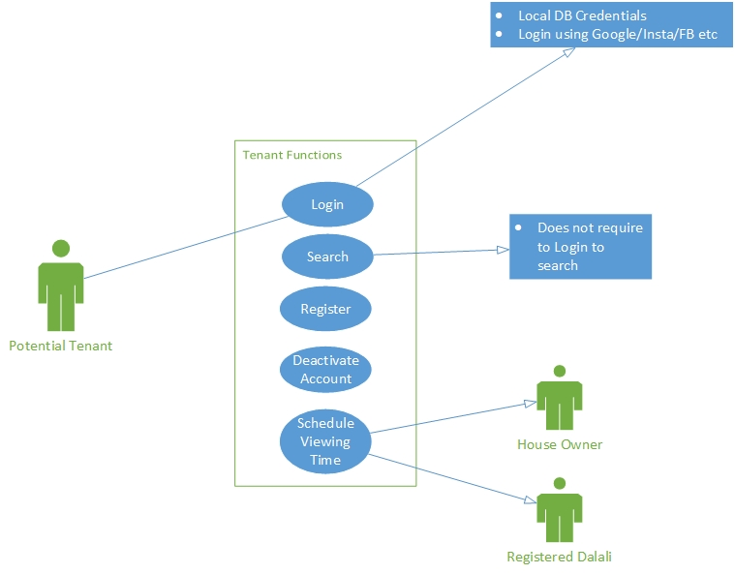

1. Schedule viewing time – schedule time to view houses either with a registered dalali if the owner had selected one or with the owner of the house.

## Registered Dalalis

Pending…………

## Database Design

Tables and relationships include User, house etc.

|  |  |
| --- | --- |
| Table | Columns |
| User | * ID auto increment, PK * Firstname * Surname * Type * etc |
| House | * ID auto increment, PK * user_id , FK belongs to user table * Type * Location * etc |
|  |  |

## Monetization Model

1. Subscription as a Service – owners of the houses are to be charged an amount advertising their houses. This is broken down into three plans

* Basic – This is the entry level plan. No images/videos are allowed to be uploaded by the user. Users will be able to add a short description of the house.
* Standard – Enables the user to add description plus upload images and videos but limited to the number they can upload and size of video.
* Premium – Enables the user to add descriptions plus Images/Videos up to a certain allowed number. This plan also gives the owner an option to add keywords *

All three plans are subject to a specified period where houses can be searched.

1. Keywords – Owners of house have an option to bid on keywords e.g. Mbezi, when a user searches for houses in Mbezi, the search algorithm will first filter out their house based to see IF it matches the criteria and if it does then displays the result first on the list. **This needs further discussion as it’s our job to provide the correct results not the results based on bids \***

## Go-to-Market Strategy

1. Target Audience –
2. Marketing Team –
3. Radio Presence -